**Sludge-Traversing ROV**

P. Dasa, E. Vijayaragavanb, A. Sarkard, S.A.R. Devalanb, V.P. Dubeye, N. Aryanf .

a Department of Electronics & Communication Engineering, SRM Institute of Science and Technology, Kattankulathur, Tamil Nadu 603203, India.

b Department of Mechanical Engineering, SRM Institute of Science and Technology, Kattankulathur, Tamil Nadu 603203, India.

c Department of Computer Science and Engineering, SRM Institute of Science and Technology, Kattankulathur, Tamil Nadu 603203, India.

d Department of Electronics & Telecommunication Engineering, Jadavpur University, Kolkata, West Bengal 700032, India.

**Abstract**

Underground pipe systems are a key to any modern 21st century settlement.​ They can vary from gas pipes to water supply and it is key to ensure that the pipes are maintained to be kept in good condition which can otherwise lead to explosions in case of gas systems and loss of water or water supply poisoning in case of water systems. ​These pipeline networks can be extensive and difficult to survey for ordinary human and human tools especially in third world or developing countries where funds and resources for such an endeavour is scarce.​ Human effort is not the solution to 100% to a country like India where faults and error rate is quite high and on the other hand we have only human labour to rely on.​

**Introduction**

To navigate sewers in order to find structural ​faults/cracks and also to lay pipes for ​cleaning.​ While toilets are a necessary part of the solution, an arguably bigger yet often overlooked issue is how to contain and treat India’s sewage.​

Untreated sewage is the leading polluter of water sources in India, causing host of diseases. In some places, the cleaners are generally very poor men who dive into the toxic sludge to clean it.In others, manholes are lifted and pumps are used to clean the sewers. ​A total of 631 people have died in the country while cleaning sewers and septic tanks in the last 10 years, the National Commission for Safai Karamcharis (NCSK) said in a response to an RTI query in 2020.​ Sewers in Indian cities are not well-developed. There are no pathways in the sewage system along which people can traverse. ​

While India’s largest cities have centralised sewage systems with underground pipes, pumping stations, and treatment plants, these systems are expensive to build and to operate, requiring uninterrupted power, skilled operators, and extensive maintenance which are not organised well in the country.​ Such sewer lines prevent engineers from examining them and the entire architecture from within.​

An ROV can be used for sewage inspection so as to spare humans from entering potentially dangerous places and also thoroughly inspect nooks and crannies of drains thus saving time and human effort. ​Manual inspections with outdated equipment result in a slow inspection rate with higher probabilities of errors.​ On the other hand, using ROV equipped with cameras can go into areas inaccessible to humans and detect corrosion. It can even expose structural problems and damages in drains and pipes.​

Using computer vision the ROVs can analyse and process the video stream and detect the structural integrity of the sewage pipelines. ​ Sensors can be fitted into the ROV to detect and measure the existence of harmful gases and substances. ​All the data will be transmitted to a software or an application where the ROVs can survey a large area in a relatively short period of time and can process and send the information using embedded systems in a relatively short period of time thus resulting in planning of an effective rescue operation whenever necessary. ​

Smaller ROVs i.e. mini drones have the added advantage of being able to fit into smaller places where humans can't therefore produce more data for processing and even capturing higher quality images of every small fault in the sewage drains. This also results in production of a large amount of data for image processing and for future reference.​

**Methodology**

*Structure*

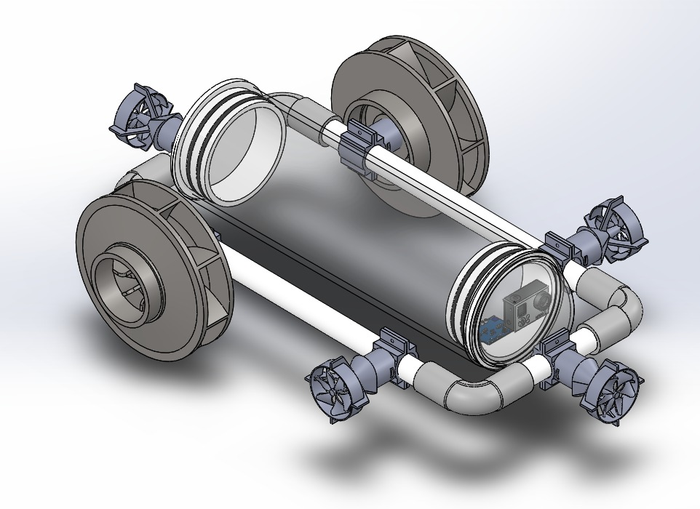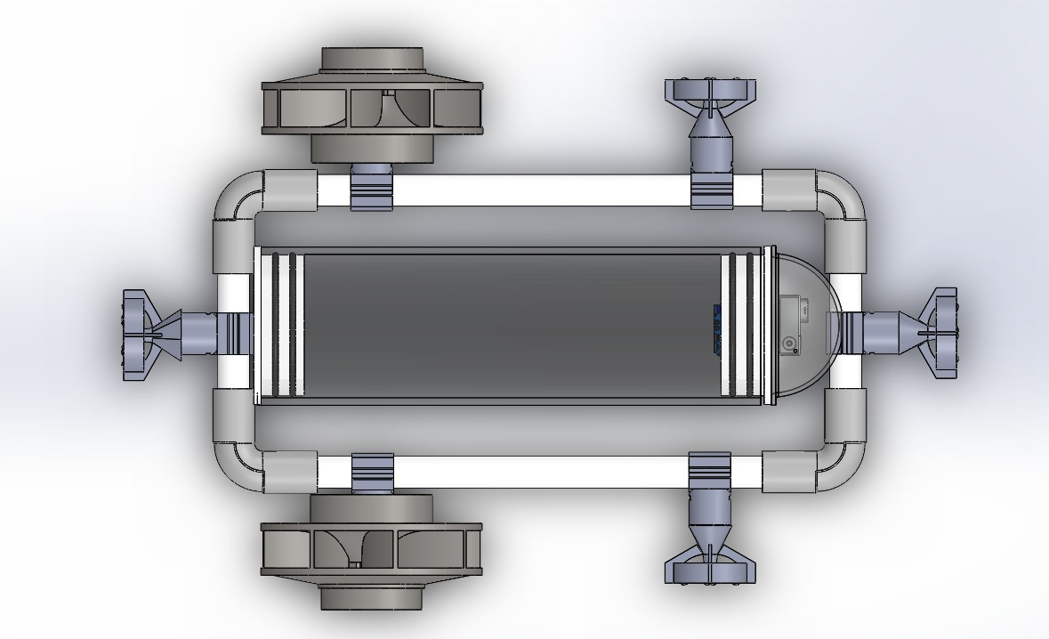

(a) (b)

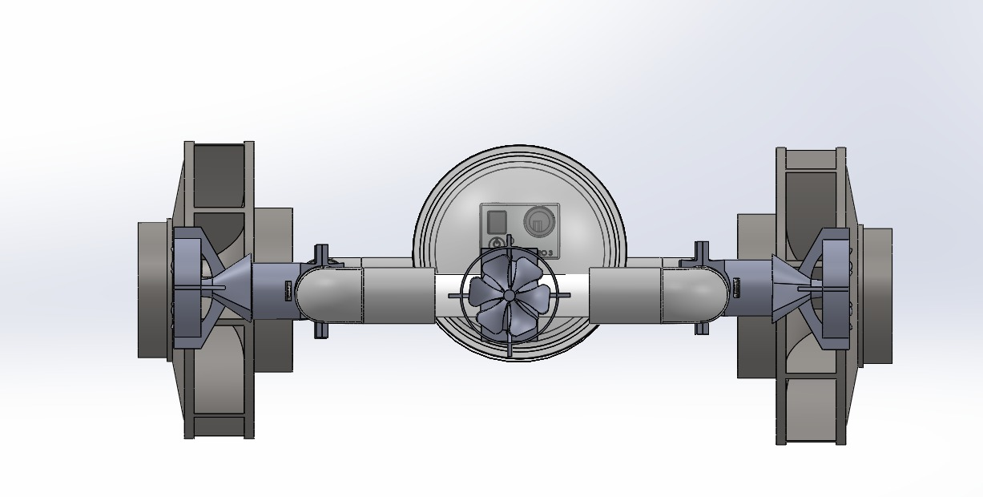

(c)

*Fig. 1: (a) Isometric view, (b) Top view, (c) Front view of the ROV model*

The model contains two big flappers which work similar to impeller and four Propellers identical to the spacecraft propulsion system. The Chassis is made of PVC Pipes to give a buoyancy over the model as similar as Ring Buoy. A Cylinder body is placed at the centre of the assembly to maintain the centre of gravity as well as to place the circuits safe from the sewage. The Propellers are connected to the respective control system along the wire passing through the PVC Pipes. PVC material is one of the budget friendly and water resistant materials to be used. Acrylic Glass is entirely a water proof solution for achieving both transparent and waterproof. A Propeller is attached to the front of chassis to redirect the ROV in case of an obstacle along with the help of supporting front propeller drive. Flappers accelerate the forward motion by overcoming the solid obstacles easily. Due to Void spaces in the body, the product would get buoyancy easily hence it floats over the sludge.

*Hardware*

An Arduino Nano V3 controls the ROV circuit, which is connected to the topside master via the tether using RS232 serial communication. On board the ROV, the Arduino sends commands to the thrusters and the camera pitch servo.

There are total 16 electronics components use from sensors to brushless dc motor, to work with a brushless motor but any esc can be connected to any receiver.ECS is nothing but Electronic stability control (ESC) helps prevent a vehicle from skidding – and the driver from losing control of his or her vehicle – when turning a corner, braking sharply or making a sudden manoeuvre.

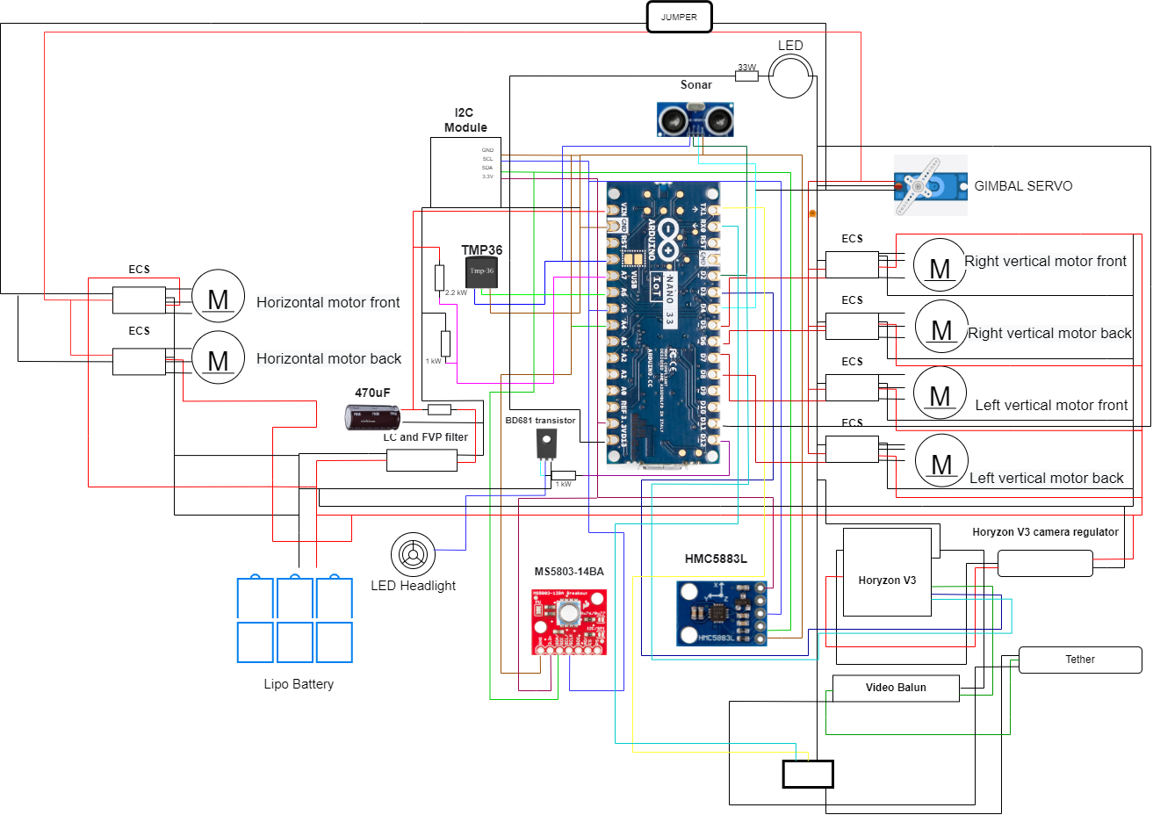

*Fig. 2: Circuit configuration of sensors and electromechanical parts with microcontroller*

Starting from different sorts of transistors, capacitors and resistors a circuit has been successfully drawn out of it. There are a total of 4 sensors used as the digital compass , pressure sensor, sonar sensor and temperature sensor. Arduino nano is the microcontroller which is a complete, breadboard-friendly board based on the ATmega328P released in 2008. It offers the same connectivity and specs of the Arduino Uno board in a smaller form factor. Along with it for the live footage of the video input Horyzon V3 along with its regulator and balun connected to the gimbal servo to control to its axis.

*Software*

ROV offers a computerised answer for the assortment of ecological surveys underwater. While they give a compelling arrangement in situations where their errand is restricted to fundamental sensor information assortment, administrative control by an administrator is as yet expected to settle on more confounded choices. Since crude information of the camera and sonar data is too enormous to be conveyed acoustically submerged, the evaluation of the information is performed post-mission. This postponed admittance can anyway prompt insufficient information assortment and longer activities that rely upon the information must be done after the information has been gathered. To improve the situational mindfulness and navigation abilities of ROV.

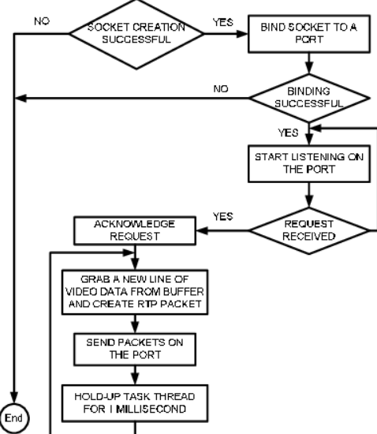

*Fig. 3: Interfacing algorithm for hardware and software*

The submerged environment yields an unforgiving nature for acoustic correspondence as a result of now is the right time to change multipath engendering and frequency-subordinate constriction, coming about in time-fluctuating frequency-selectivity and just a restricted acoustic data transmission that can be utilised effectively. Hence, to give critical information rates, e.g., to communicate video, stage cognizant acoustic tweak techniques are required that effectively utilise the restricted accessible transmission capacity. The adaptable phase-coherent tweak procedure is named Multi-Stream Frequency-Repetition Spread Spectrum (MSFRSS).

**Result**

By utilising the referenced convention, we can without much of a stretch communicate usable data like sound, video, and any of the climate measurements. We are attempting to minimise the network lag between the host and remote transmission. The payload communicated will be not corrupted and dependable. Our fundamental objective is to give precise information to our remote operator, and interior logs will be kept up with on the off chance that any device failure at any point occurs. Video encoding will have somewhere around 720p transmission with the goal that the operator can undoubtedly see the submerged climate substantially more clearly. The picture shown here will be the actual footage of the ROV. Currently in the prototyping phase and has various room for improvements For eg:- night vision, thermal imaging, video compression for transmission, etc.

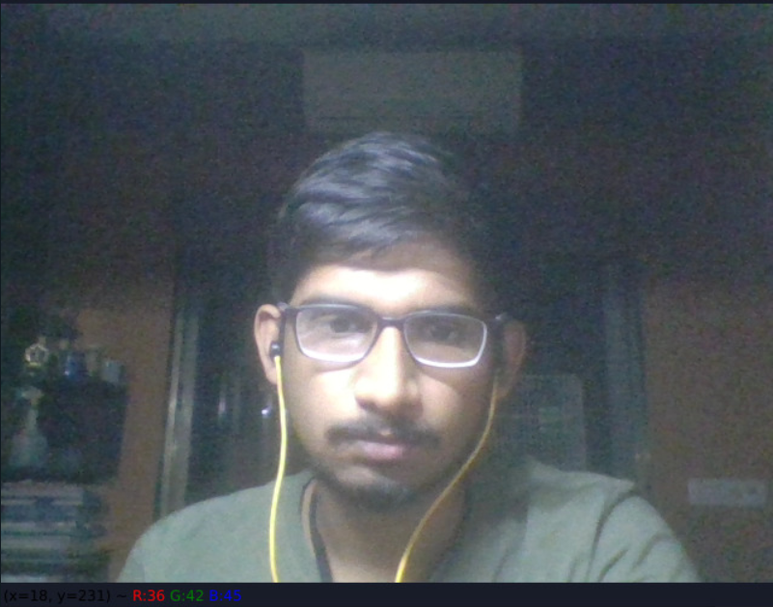

*Fig. 4: Testing of 720p video capture*

Sewer inspection and conditional assessment is done either manually through inspection teams or visually through recordings of the pipelines taken by a camera connected as a CCTV. However both of these methods require long and meticulous human effort which results in lost time and budget. The objective in this research is to automate the earlier mentioned process using computer vision and sensors which constantly feed data to our systems.The computer vision approach is thus completed as follows. First, the raw image is pre-processed and optimised for the model. Following that: i) the ROI ( Region-of-Interest) model returns a region with the highest probability of a defect or a fault in the pipeline ii) which is then fed into the classifier CNN (Convolutional-Neural-Network) model to decipher exactly what it is. The presented algorithm has been designed and tested as per datasets from CCTV inspection reports and other manually annotated open-source datasets.

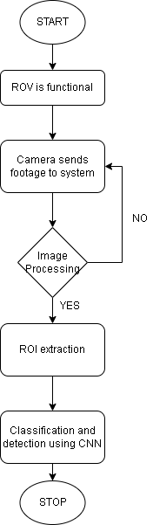

*Fig. 5: Image processing flowchart*

**Conclusion**

Lastly our team would like to conclude that, living in the 21st century where we can utilise the concept of ROV , which will be able to detect any sort of failure in underground tunnels and be very well used for sewage inspection.​

In a country like India we need a upgradation to a level of benefit, to make the impossible happen with a very cost effective price for the government or the investor to invest in. ​The concept of making a water resistant mini ROV is what makes our project, our research work, our mission stay out of the crowd in the world of ROVs when it comes to our country, India. ​

We often have come across many such ROVs for limited purposes, but here we want to come up with a concept that every country should put their investment in for a better, smart and a sustainable future. ​Our goal is to make an ROV , rather a sustainable one for our future generation to rely on in a quick and effective manner.

**References**

1. <https://www.researchgate.net/publication/311614984_Subsea_Infrastructure_Inspection_A_Review_Study>
2. [(PDF) Asset Inspection Powered by Computer Vision: The Use of Deep Neural Networks for Automating the Detection and Classification of Pipeline External Damage (researchgate.net)](https://www.researchgate.net/publication/350457978_Asset_Inspection_Powered_by_Computer_Vision_The_Use_of_Deep_Neural_Networks_for_Automating_the_Detection_and_Classification_of_Pipeline_External_Damage)
3. [(PDF) Vision-Based Pipe Monitoring Robot For Crack Detection Using Canny Edge Detection Method As An Image Processing Technique (researchgate.net)](https://www.researchgate.net/publication/320115527_Vision-Based_Pipe_Monitoring_Robot_For_Crack_Detection_Using_Canny_Edge_Detection_Method_As_An_Image_Processing_Technique)